Create an app which will let the user render a page of a pdf document like this:

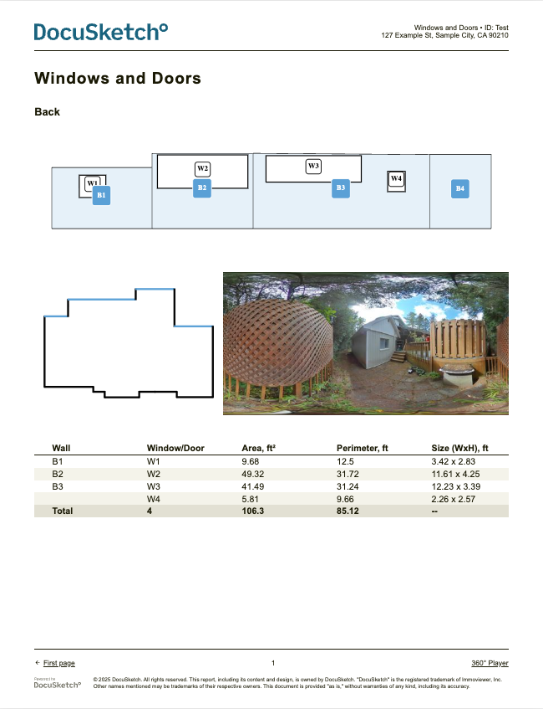

Make sure that you use the following technologies:
- SCSS
- WeasyPrint
- HTML Templates
- SVG rendering
- Streamlit app

Mission/Goal
Create an architecture which can be scaled to many pages and is dynamic enough to add new pages easily. Make sure to render a pdf page which can be displayed in chrome by using the technologies listed above. Additionally, create a streamlit application in which it's easy to change the numbers in the table and replace the svg that is rendered as the top down projection.

Data

All files are found in this shared google drive folder:
https://drive.google.com/drive/folders/1cxJjAkUplMYrcnqH00l5Qxy1z8rybm5Y?usp=sharing

Files inside this folder:
- new_logo.svg Docusketch Logo
- new_logo_powered.png Power by Docusketch Logo
- top.svg Render of the top side wall projection
- table_data.csv data for the table to render
- walls.json
  - Data for each wall in order to render the 2D top down projection
  - use an algorithmic approach to compute which walls should be blue
- pano.jpg panorama image

